Assoc. Prof. Dr Sabahudin Hadžialić

World as global sin: “Eskimos“ Learn along Side Bosnian’s
"It is no measure of health to be well adjusted to a profoundly sick society“
J. Krishnamurti
Indian philosopher and writer
“Scholar is always a scholar, and the king only rules his kingdom” - Indian proverb. Yes, words of this Indian proverb could easily be understood, if the situation was some-what different then it is in the education system of BiH.
Namely, when questioned to which ethnic group they belong (read: nation), in the scope of researches done as decided by the ministry of Education, science, culture and sport about equal use of Bosnian and Croat teaching plan in elementary and secondary schools, between 18 and 20 % students of the Second Gymnasium Sarajevo (High school), and who, according to the school director stated that they are Bosnian. Significant number of those registered in the category of “others” should be added to this as well as those expressing their nationality as Chinese, Eskimos or Bulgarian …
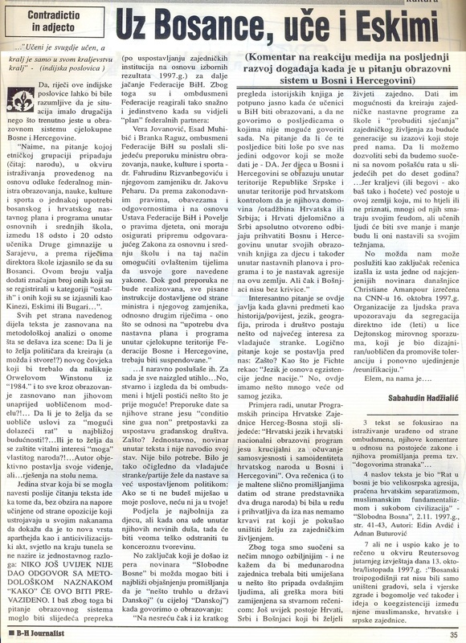
All five sides of this part of text are based on Methodological analysis of what is happening behind the scene: Is the wish of Politicians to design (or maybe create), a new person who should be alike George 0rwel’s Winston from “1984” and all that based on an already formed model!?… Is that a wish to create conditions”for possible upcoming war“ in the nearest future! Or this is a wish to protect vital interests of “my” own people! Author objectively presents his view, but …the solution is not on the table yet.
The only thing that could be said after you read this text goes towards the fact that regardless of opposition’s efforts and managing to remain at their stand to prove that this is a new kind of apartheid as well as a non civilized act, light at the end of the tunnel cannot be seen yet for the simple reason:
NO ONE HAS ANSWERED WITH METHODOLOGICAL APPROACH ”HOW” WILL OVERCOME THIS.
This is the reason why education system could be the next obstacle (after establishing joint institutions based on election results 1997) in the further strengthening of FBIH.
Therefore, Federation Ombudsmen reacted strongly and unanimously when they saw Federal partner’s plan: Vera Jovanovic, Esad Muhibic and Branka Raguž, FBIH Ombudsmen send the following recommendation to dr. Fahrudin Rizvanbegovic, Min. of Education and his Deputy, dr. Jakov Pehar, that according to legal legislation, obligations and responsibilities based on FBIH Constitution as well as the Charter of child rights, they have to prepare laws for Elementary and Secondary Schools and enable administrative bodies to adopt above mentioned laws. Until this recommendation is implemented, all written instructions forwarded by Minister or his Deputy, in other words –those relating to “use of two teaching plans inside the whole territory of FBIH should be suspended.”
…Of course they were obeyed. For now everything is silent… However, it looks as if Ombudsman would like to achieve something as soon as possible! Recommendation given is “Conditio Sine Qua Non” of recommendations for establishing a civic society. Why? Simply, the Journalist has not stated his view point in the text. There was no need. It was so obvious that parties in Government wish to continue with already established politics: If you do not interfere with my business I shall not in yours!
Division is the most painful for children, but when it enters their innocent souls, it will be very difficult to remove this malignant matter. The conclusion that came from the Journalist of Slobodna Bosna magazine could be the closest to explaining “that something is rotten in the state of Denmark” (in the whole of „Denmark“), speaking of education...quote: ”unfortunately just by looking at history books it is clear when the students in BIH will be educated, not to speak of consequences of which it is not possible to speak at all. If questioned whether those consequences will be bad for all of us, the only answer one can give is –YES. Since children in BIH are educated inside RS and Croat controlled areas that their homeland is Croatia or Serbia: Subsequently, Croats in part and Serbs absolutely openly refuse to accept BIH inside books for children as well as teaching plans and that is a continuation of aggression on this country. Not even Bosniaks (Muslims) are without guilt.”…end of quote.
Interesting issue arises in the form of main subjects such as history, language, geography become something of an outmost interest for the ruling parties. Therefore, logical question put before us is - Why? Just like Fichte, German philosopher said: “Language is the basis of nation’s existence.” However, what we have here is bigger than language itself. Just as an example, program principles of HZHB(so call Croatian Republic of Herzeg-Bosnia) state the following: ”Croatian language and Croatian national program are crucial for preserving self-identity of Croat people in BIH .” This sentence (which is more or less similar to the opinions given by representatives of two other nations – Serbs and Bosniaks -_Muslim) would be acceptable if we did not have a bloody war behind us which tried to destroy the will for living together. Consequently we are faced with something much more serious - and I am not stating that International Community should be involved in something that belongs to local people but mistake must be corrected with a real sentence: There are still Croats, Serbs and Bosniaks who wish to live together. To give them a possibility of creating a joint teaching program for schools and to “awake the memories” of living together are challenges for future generations ahead of us. Can we allow ourselves to be faced with new horrors of war in the following 5 to 10 years?
… Kings (or Beys if you like it that way ) already exist in this country and many of them, whether we like it or not, consider it their own feud, but less and less scholars will remain if they continue with their intentions.
Maybe a statement of Christian Amanpour, one of the most appreciated journalists of these days, broadcasted on CNN on October 16, 1997 can serve us as a conclusion: HR Organizations warn that segregation is flaying directly in the face of Dayton Peace Accords which was designed to promote a tolerant society and reunification .”
Well ,it’s up to us…
This essay above was written by this author and publish on 08/12/1998 in BH Journalist (well known magazine of BH Journalist Union, 19 years ago in Bosnia and Hercegovina)
Nineteen(19) years later, today in 2017 we still have the same situation. Ups, sorry, no, we do not have. Why? Because one complete generation became mature and ready to cast their Bosniak(Muslim), Serb and/or Croat vote. What do you think? Would they vote for peace or war? I think the answer is so obvious.
p.s. What about us, so call others from the Constitution: Bosnians and Herzegovinians? Nothing, because we are just Eskimos from the South of Europe, a simple minority, with no basic human right. Yes, my dear World. Just “Google us” and you will see that chauvinism and nationalism from all three sides made us minority and “others” within our own country. So, Poland on 12.11.2017 and nationalistic protesters who disrupted Poland Independence Day events this Sunday is just beginning for the Europe. You did not learn anything from the dissolution of former Yugoslavia, anything at all.
So, please, World, do not be the sinner. Learn from us.

