Prof. Dr. & Dr. Honoris Causa
Sabahudin Hadžialić

Virus Balkanicus – Fascist Chauvinism:
The beginning of the end or The end of beginning

The goal must be to change the system, not just the regime
The light breeze, which happened with “Worker’s front” (Radnička fronta) continued with the positive wind Political platform “WE CAN!” (MOŽEMO!) in Croatia. However, to have a positive hurricane, we need a change of the system and not just change of the regime. Again, to meet a state of social justice it has to be done: RIGHTS = RESPONSIBILITY; RESPONSIBILITY = EMPATHY and EMPATHY = EQUALITY. There are differences, although both above political parties are left wing, between them. First one is more radical and the second is moderate left wing, whatever does it mean within the current post-transition, clientelistic, opportunistic and nepotistic post Yugoslav country of Croatia.
Namely, the positive wind is city of Zagreb, which has a new Mayor, the leader of left-wing coalition “WE CAN!”, Mr. Tomislav Tomašević (1982), as of Sunday, 30.5.2021 with approximately of 65 % of votes from those registered 45,07 % of the votes, which is in number – almost 200.000 votes.
The difference between, for example, Zagreb (Capitol of Croatia) and Belgrade (Capitol of Serbia) in 2021 is that Zagreb recognized that genocide has happened in Srebrenica (Bosnia and Herzegovina) and recognized independent state of Kosovo, but Serbia does not. Map of former Yugoslavia (1945-1991):
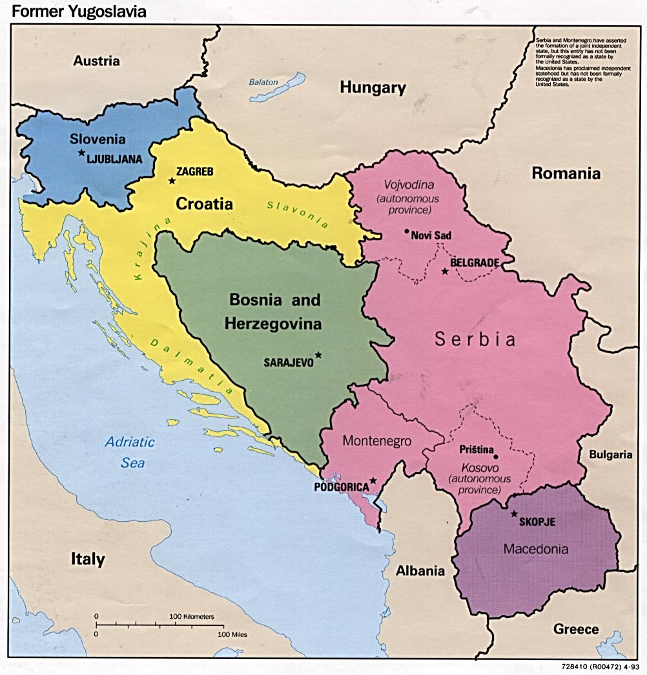
Photo 1. – Map of the former Yugoslavia
However, to meet wishful hurricane, we have to meet also catharses thoughts that both, Croatia and Serbia have done an aggressions during the war in former Yugoslavia (1991-1995) on Bosnia and Herzegovina.
In addition, neither Croatia and/or Serbia have so far recognized that their military and paramilitary forces have committed any war crimes during the war(s) back in the nineties of the XX century, within the area of former Yugoslavia.
To be able to meet that, we just need, as said above – change the system, not just to change the existing regime(s).
Changes or the dust
Therefore, methodologically, what exactly has to change within any country that came out from the dissolution of the Socialistic Federal Republic of Yugoslavia?
- Judiciary system
It is not enough to give high salaries to the judges, prosecutors, and say: “Now, they are independent”. It has to have created responsibility of them to answer to real independent commission(s) within the any part of the countries (i.e. from the municipal up to the Supreme Court). At least every six months.
- Political system
The system of responsibility does not exist at all. Even if somebody is “overthrown” from the position. If he/she have collected a huge amount of money through the clientelistic, nepotistic and corrupted system within any of the countries of ex-Yu (to add as well to the mentioned ones: Croatia, Montenegro, North Macedonia, Kosovo*, Slovenia) he/she keeps the money and run. BTW, reminds me on an excellent song from the Steve Miller Band back from 1976 – “Take the money and run” from the album Fly like an Eagle.

- Social and economic system
It is very expensive, today, within the countries of former Yugoslavia, to cure yourself (if sick), to live and to, even, die. Main slogan of those who was just a bus drivers and/or genitors prior to the “democracy” within those areas is: “Democracy is the chance to develop your knowledge of existence”. My answer re that is: “All animals are equal, but some are more equal than others. “ (Quote from the book “Animal farm” of George Orwell - 1945). Why? Because, it is not the knowledge that creates the development of the existence within the democracy. It is a membership of the party. They have changed the dresses and from the red membership of the party became green and/or blue and/or yellow. Depending of the current need.

- Education system
Buying (plagiarism, corruption – some words from me to Radio Free Europe / Radio Liberty back in October 2020) all kind of diplomas is the trend within the area of former Yugoslavia, because less you know (and obey more) better you climb on the stairs of success. Science is on the burn like “witches” during the inquisition time in the Middle Ages. Just check the citations indexes of the members of the Scientific councils within any of the countries governments. Knowledge changes every 12 hours within this digital world of ours, today. Within the area of former Yugoslavia, the knowledge is changed, but backwards.

Therefore, welcome to the area where everything is possible. Even a wooden stow, if said so by local political and/or religious leader(s). Because, anyone who promote literacy here (especially critical thinking observation - media literacy) is like to be a Jewish in Nazi Germany.

Do not believe me? Ok, one example: Myself, who has two doctoral degrees does not have enough “knowledge” to work within any University so far within any of the University within any country of former Yugoslavia, but has the knowledge to work in European Union: Lithuania, Poland, and Italy.

So, which knowledge you prefer?

If your answer is “knowledge” than my answer is the following:

The changes that are happening in Croatia now, from Sunday, 30.5.2021 will not change the system, but will change the regime and it is the end of beginning.

Although, if your answer is knowledge than you have to be ready to be more radical within the changes that has to be done to meet the knowledge as requested. In which kind? To make, along with these changes in Croatia, a flood of changings within the system that will create the beginning of end of the regime(s) that exists within all countries of former Yugoslavia.

For the benefit of all, not just a few, within the system(s).

