Assoc. Prof. Dr. & Dr. Honoris Causa
Sabahudin Hadžialić

Virus Balkanicus – Fascist Chauvinism:
Montenegro uber alles and the never-ending story
Can you imagine that a street in Vilnius (Lithuania), 25 years later — after WWII ended — would be named after Hermann Göring (1), the head of Hitler’s Gestapo?
Can you imagine a street in Kampala (Uganda), 25 years later — after the Rwanda genocide — named after Ladislas Ntaganzwa (2), one of the main responsible politicians for the murdering more than 200,000 people?
But, you can see such a reality in the area of former Yugoslavia, where many streets are named after Croatian fascists from WWII.
For example, there is the Mile Budak Street in Mostar, Bosnia and Herzegovina since 1995 and until today (Budak can be seen in the photo and is the second on the right marching with “Heil Hitler” greetings during World War II). Budak has additional streets in Jasenice, Pag, Pakoštane, Pleternica, Sisak, Sveti Rok, Vinkovci, Vrana and Zadar and, strangely enough, a pier in Bilice, Croatia (3).
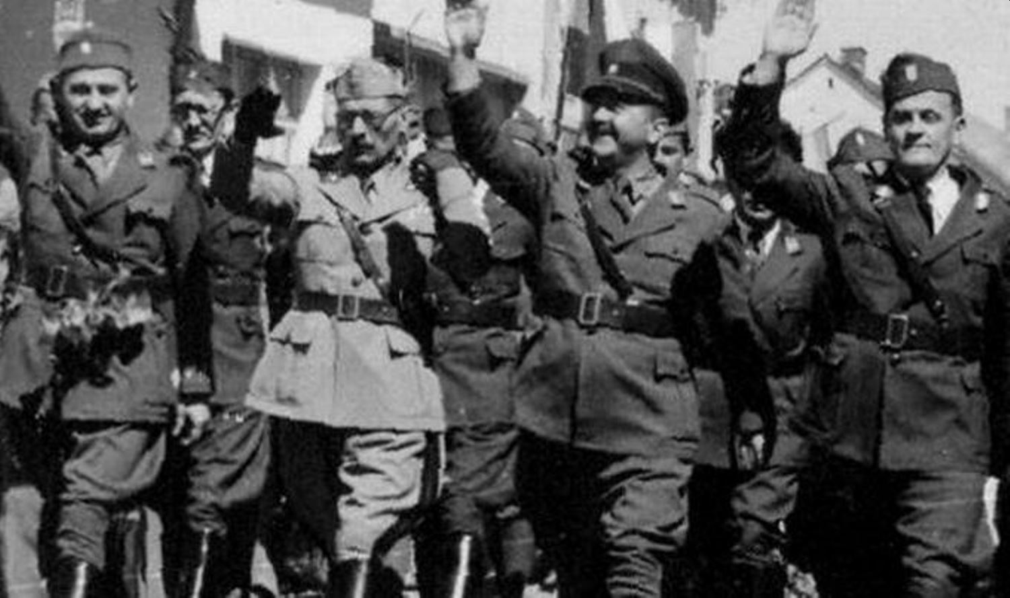

You can also see this reality in the area of former Yugoslavia, where streets are named in honor of Bosniak fascists from World War II, such as Mustafa Busuladžić (4) after whom many streets and schools are named.
Busuladžić was a notorious anti-Semite and Nazi collaborator in the WWII.
Mustafa Busuladžić photo:
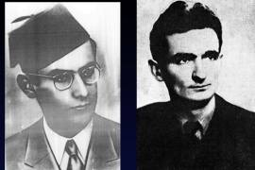

Amazingly, you can also see this reality in the area of former Yugoslavia, where streets are named after Serbian prosecuted war criminals from the recent war in Bosnia and Herzegovina (1992-1995), such as the Street of General Ratko Mladić (5) in the village Božanovići, former commander of the Army of Republika Srpska.
Check out this Ratko Mladić War Photo and and an important short 12 second interview of his on this link Srebrenica, when genocide started (English subtitle) (6)
It doesn’t stop there, as you can see this reality in the area of former Yugoslavia, the streets are about to be named after Serbian prosecuted war criminals from the recent war in Bosnia and Herzegovina (1992-1995), such as Street of General Ratko Mladić (7) in the city of Berane in Montenegro, former commander of the Army of Republika Srpska. Advisory council in Montenegrin town supports naming street after Ratko Mladic on 5.2.2021. (8)

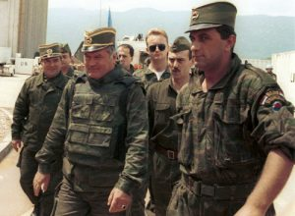
General Ratko Mladic (centre) arrives for UN-mediated talks at Sarajevo airport, June 1993. (Source: Mikhail Evstafiev)
In other words, it can be seen from the above mentioned examples that ‘streets and schools” are not the exceptions, but the rules which are promulgated in Montenegro after the “re-establishment of democracy” in this country since the last elections, whatever that means.
Populism always leads to the fascism and/or totalitarian society (as we could see in Nazi Germany and in the USSR) and recently with fascistic chauvinism in Croatia, fascistic chauvinism in Serbia, fascistic chauvinism in Slovenia and with fascistic chauvinism in Bosnia and Herzegovina.
In Montenegro, the majority that has ruled the country since the August 2020 elections does not recognize that genocide happened in Srebrenica, Bosnia and Herzegovina — and the country which slowly drives from theocracy into the “clero-fascism” shows itself as being occupied by the same religious fanatics and fundamentalists who were on the front line of genocide in Srebrenica, back in 1995. Never forget, please, that even Hitler came to power through democratic elections in 1993 and democracy cannot exists if does not apply this formula which I established in 2020:

Rights equal responsibility

Responsibility equals empathy and

Empathy equals equality

Rights equal responsibility, for Montenegro and as well for other above mentioned countries that came out from the former Socialistic Federal Republic of Yugoslavia, that as many rights I gain there is an equal responsibility I have. You cannot take, like from Swedish table only, what is suitable only for you — because my freedom stops when I jeopardize the freedom of others.
Responsibility equals empathy means, that responsibility goes together with empathy having in mind the most vulnerable, minority groups within your own country. Empathy does not exist when you glorify war criminals and fascists.
Empathy equal equality, means that really “all animals must be equal and not ones more than others”, to paraphrase George Orwell in the “Animal Farm” book from 1945 (9).

This problem in the area of former Yugoslavia is not just a problem for that area, but indeed is the World problem of the 21st Century. The rise of populism, nationalism and fascistic chauvinism has been shown through the immigrant crises, anti-Semitism, anti-Islam, anti-Christianity.

The World has really become in 2021 a global sin as I said in my book “World As Global Sin” back in 2018.
Hope dies last, but how are we to hope within the world faced with pandemics that seems to never stop, having as a cream above the creams a fascistic chauvinism that sees the enemy in the “others and those who are different”?
Questions have answers within each soul of this planet and we will talk about it, whoever survives, after this civilization ends. Or, perhaps, this has already happened, but nobody told us. Us, who are living in a matrix of lost, last hopes.
Notes:
- Reichsmarschall, Commander of the Luftwaffe 1935–45, Chief of the 4-Year Plan 1936–45, and original head of the Gestapo before turning it over to the SS in April 1934. Originally the second-highest-ranked member of the Nazi Party and Hitler’s designated successor, he fell out of favor with Hitler in April 1945. Highest ranking Nazi official to be tried at Nuremberg. Committed suicide the night before his scheduled execution.
- https://www.abc.net.au/news/2020-05-29/ladislas-ntaganzwa-life-in-jail-for-rwanda-genocide-role/12298996
- https://forward.com/news/462695/nazi-collaborator-monuments-in-croatia/
- https://www.rferl.org/a/bosnia-sarajevo-school-renamed-busuladzic-nazi/28698295.html
- https://balkaninsight.com/2020/05/19/ulice-i-trgovi-u-bih-nose-imena-ratnih-zlocinaca/?lang=sr
- https://www.youtube.com/watch?v=U0_Tp66MYRU
- https://balkaninsight.com/2020/05/19/ulice-i-trgovi-u-bih-nose-imena-ratnih-zlocinaca/?lang=sr
- https://rs.n1info.com/english/news/advisory-council-in-montenegrin-town-supports-naming-street-after-ratko-mladic/
- https://literarydevices.net/all-animals-are-equal/

