Assoc. Prof. Dr. & Dr. Honoris Causa
Sabahudin Hadžialić
Media ethics in professional journalism:
Term and Types of Ethics – I part
TERM AND TYPES OF ETHICS
Ethics is the branch of philosophy which deals with moral components of human life and usually is called philosophy of the morality. Ethics reflects understandings of the society about what is and what is not correct within the certain act as well as differences between a good and evil. If you accuse somebody that he is lazy and does not do his job well, that does not mean that he has immoral behavior. From other side, lying and robbery implicit violation of ethical norms. That is why ethics is very often described as agglomerate of principles or as codex of moral behavior.
Our conscience is telling us, even in the journalism (of course if we have that conscience) very often in brutally clear way, that there is a significant difference between the acts that are accurate ones and the acts that are wrong. Knowing ethical principles and the facts from which it has been derived can make influence on our behavior.
When, for example, journalists „dive“ into someone's life, their decision to publish, and it is very often, unpleasent details, they justify „people's right to know“. The problem with that justification is that it does not answer the question exactly what people has right to know, and before everything, why people has the right to know this kind of information.
DEFINITION OF ETHICS AND INSEPARABILITY FROM JOURNALISM
All over the world codes of conduct have been proposed for journalists. In fact ethics is inseparable from journalism, because the practice of journalism is centred on a set of essentially ethical concepts: freedom, democracy, truth, objectivity, honesty, privacy. If the proper role of journalism is seen as providing information, then the ethical questions focus on one issue: maintaining the quality of the information. This issue has become a matter of political controversy and public concern. Many people think the media are inaccurate and biased.
The Robert Maxwell case has re-opened the issue of media ownership. Questions of censorship and freedom of information have arisen in connection with Spycatcher, the fight against terrorism in Northern Ireland and the wars in the Falklands and the Gulf. Not to mention issues with ISIL. There is much concern about the trivialising and exploitative representation of women in the media, etc. The dissemination and discussion of information concerning the major problems the world and its people face is necessary to both the democratic understanding and the democratic action without which the problems cannot be solved – without which, in fact, they will escalate.
So here is great opportunity for the media to contribute to the advancement of peace, prosperity and progress. With one fifth of the world's population – one billion people – in a state of dire physical need, questions about the production, distribution and consumption, the ownership and control, of he world's material resources will continue to be a central relevance and importance to the political agenda. Turning from the global to the national level, we find that the issue of quality is still inescapable. A free and vigorouss press and other organs of mass meida and mass communications are agreed to be amnog the essential ingredients of a healthy society.
Why I used a word „vigorous“? Because it is clear that freedom is not sufficient: a press could be free yet timid or torpid. Ethics is not just a matter of codes of coonduct (plus or minus sanctions), not just a matter of rules to be followed. It is more to do with principles concerning the rights and worngs of human conduct, principles which have some reasoned theoretical basis and which therefore apply objectively and impartially.
ETHICS AS THE PHYLOSOPHY OF THE MORALITY
Although different writers use the words "ethics" and "morals" in different senses, in this course we will make the following distinctions to help avoid equivocation or these terms in ethical arguments.
Morals is best studied as psychology, sociology, or anthropology. Different societies have different moral codes.
2. Morals is a descriptive science; it seeks to establish "what is true" in a society or group.
3. Often morals are the shared ideals of a group, irrespective of whether they are practiced.
4. In the sense of descriptive ethics or morals, different persons, groups, and societies have different moral standards. This observation is seen as true by all sides.
a. We would commit the fallacy of equivocation to conclude from this observation that there is no universal ethical (q.v., below under I, B) standard.
b. We can only conclude by observation that there appears to be, or is, no universal moral standard.
c. This confusion between descriptive and prescriptive ethics occurs quite often by persons untrained in philosophical analysis. Isaac Asimov got it right when he wrote, "Never let your sense of morals get in the way of doing what's right."
OBJECTIVE VALUES (RIGHT AND WRONG)
In a sense, morals are the study of what is thought to be right and what is generally done by a group, society, or a culture. In general, morals correspond to what actually is done in a society.
One guy with the name Hinc has a wife who is dying of cancer. Without any success, he has tried to collect the money for buying the medicine. Cure cost 2000 USA $ dollars and Hinc succeeded to collect 1,500, but pharmacist did not want to sell him the cure on credit. Should Hinc steal the cure to save his wife? This famous hypothetical thesis social psychologist Lawrence Kohlberg and his associates have used to illustrate opposed values which are rooted in the comprehension of justice. From one side, Hinc loves his wife and within the interest of the preservation of life, he would have justification to steal the medicine. From the other side, doing that he would violate one of the fundamental moral principles in the Western world – forbidden stealing of other people’s property. Hinc dilemmas are all around us. Those dilemmas make an essence of emotional debates about social issues like abortion, possession of guns, death penalties, sexual education, and pornography.
Moral anarchy
If ethical system gives moral cohesion to the individuals and institutions, then that is the most needed issue for professional journalists. Why? Mass media are among the most influential enterprises in democratic society, on the crossroads between citizens and their political, economic and social institutions.
Ethical standards should be based on the intellect and experience, but we have another very interesting issue within it – wisdom. Very often we hear things like “he is very wisdom” but what he has done might not be ethical at all. Wisdom also demands breathing room for advertisers who use “puffery” in their commercial messages, if the ads are not deceptive. Hyperbole is the handmaiden of salesmanship, and the marketplace suffers little from the introduction of exaggerated commercial claims of enhanced sex appeal and social acceptance. A code based on wisdom promotes ethical behavior while avoiding excessive and unreasonable moral propriety. Application of this criterion to a system of ethics results in flexibility, which shuns the extremes of an intransigent code at the end and moral anarchy at the other. In journalism, the proper balanced is somewhere between the sensational and the bland.
Inseparability of the Ethics from journalism:
freedom, democracy, truth, objectivity, honesty, privacy
Five criterions represent basics of any kind of ethical system, including the one that belongs to professional journalists. First, ethical system must have joint values related to the ones mentioned within the content of this Slide. Because, before bringing of ethical judgments, society must achieve agreement about the standards of moral behavior. Second one is that those standards must be reposed on reason and experience and should try to harmonize rights and interests of the people with their obligations towards other people. Third, ethical system must search for the justice. Should not be double standards within behavior, except if there is no convincing and morally sustainable reason for discrimination. Fourth, ethical system should be reposed on the freedom of choice and system of ethic which is not contained of responsibility encourages freedom without responsibility and by doing that does not have moral authority to encourage honorable behavior. And we get, as said, then – moral anarchy. Finally, my firm stand is that we should use this sentence as well in professional journalism: „As much rights I gain, I should gain equal amount of responsibilities.”
Ethics focus on the maintaining the quality of the information
In quality control – should we focus on Law or Ethics? The issue of quality is inescapable. A free and vigorous press and other organs of mass communications are agreed to be among the essential ingredients of a healthy democracy. When I mentioned “vigorous” I meant that freedom is not sufficient: a press could be free yet timid or torpid.
What is important is that the activity that wishes to call itself professional be conducted on an ethical basis and that its practitioners be accountable for their actions.
Ethics is not just matter of codes of conducts (plus or minus sanctions), not just matter of rules to be followed. It is more to do with principles concerning the rights and wrongs of human conduct, principles which have some reasoned theoretical basis and which therefore apply objectively and impartially within the quality way of presenting the information.
Yes, maintaining the quality of information, just like having a code of conduct, is the restoration of the honor of journalism.
What is true on a national level is also true internationally. A commitment to quality of information and information flow to meet the urgent and demanding need for action in a troubled world is required on a global scale. To ensure freedom of information on this scale both global networks and democratic access are essential. Here the enemies of freedom are perhaps even more formidable, through intolerant or totalitarian governments and transnational capitalist corporations are not natural allies, and to some extent their interests’ conflict. But whether censorship-ideological, religious or commercial – can prevail against the need for quality in the global media is not something that can today be predicted.

METAETHICS, NORMATIVE ETHICS AND APPLIED ETHICS

Through trying of putting questions within the wider context, ethics, as formal field of research, comprises of three different, but conceptually akin and related, so call, projects: metaethics, normative ethics and applied ethics.
Function of Metaethics
Metaethics deals with study of the characteristics or nature of ethics. It investigates the meaning of abstract concepts such as good, right, justice and honesty and try those values that represents the best moral values. This kind of ethics doesn't deal with bringing of moral judgments. For example, dedication to the truth ethicists recognize as something that is morally good and that value represents one of the foundation of social and thereby journalistic norms as well.
Function of metaethics is that in ethical sense define that kind of indeterminate concepts and to offer precision of the meaning, so, in that way, to make all the members of society could start with the process of enactment of moral judgment from the equal positions.
Metaethics offers wide foundation for ethical decision making, but does not give guidance how to get from the point A to the point B. When viewers and readers say that some report is not fair, is their concern of ethical nature or is it just the matter of taste? Of when media critics who writes that TV show is “good drama”, by doing that, he did not bring any stands in regards moral characteristics of the show.
A brief definition of Metaethics: "A classification within western philosophy that attempts to discover the origin or cause of right and wrong." An another example question within metaethics is: "How can we know what is right and wrong?" There are almost as many different answers as there are different people answering the question. Some individuals may say that right and wrong are dictated by holy books, or philosophy books, or political books, or by popular speakers, but there is not yet a good explanation within philosophy that can illustrate the origins and nature of right and wrong that are verifiable and acceptable to everyone. If the question were "how can we know that rocks fall to the ground," it would be a simple choice to observe rocks and to study the physics of Nature to gain both the personal experience of observing rocks fall as well as gaining a scientific explanation of why rocks fall. The force of gravity itself might not be perfectly understood, but no healthy mind would deny that the concept of gravity is a part of the reason why rocks fall to the ground.
Normative ethics and principles of moral behavior
Normative ethics deals with development of general theories, rules and principles of moral behavior. Certain social bans of lying, cheating or stealing originate from our relations towards normative ethics. For example: Within certain media there exists ban for the journalists to use impostures to get to the news; that ban is derived from general social norms connected with lying. Journalists, however, under the pressure of competition and deadlines, are tempted to give up on so generally shaped principles, because they would like to have exclusive story or believe that they will, through distortion of facts, satisfy public interest, even if they, by doing that, are breaking one of the basic rules of ethical behavior. When a moral norm went through baptism of fire in real world, media workers comes to the territory of applied ethics.
The real example of satisfying is, within the pressure of public, of course, normative but also applied ethics, within tabloid NEWS OF THE WORLD, owned by Rupert Murdoch, from 2011: “We have eavesdrop telephones and we are very sorry for that” was the message from Editorial board of tabloid News of the World in which was stated that saying goodbye from the almost of 7 and a half million readers is difficult and sad, but proud in the same time, shutting down after 168 years of existence. The reason for that happened after the affair with interception o telephones. Target of the journalists were always celebrities, most often, but the Scandal culminated after it has been discovered that the journalists of the News of the World intercepted telephone of 13-years old girl Milly Dowler who was, back in 2002, first kidnapped and murdered. They have apologies in the last issue, but…

Applied ethics: solving problems
Applied ethics is the branch of philosophy of the morality that deals with solving of the problems. Here you can use knowledge that are derived from meta-ethics and general principles and rules of normative ethics to solve ethical questions in concrete cases. Let us assume that the barrister of the person accused for the corruption and/or murder have kindly asked journalist to disclose to him the sources of the information he used to write an article about corruption and/or murder. Journalist has promised to his sources that he will not disclose, until the beginning of trial, their identities. Barrister, however, believes that this information would lead to the releasing of his client.
One rule or social norm tells us, in this case, that the given and promised word should be kept always, because in opposite, we are distorting a trust on which are based relations among individuals. From other side, justice requires that accused ones should have honest and objectively conducted trial.
In this case we have two abstract principles collides. Applied ethics should lead us through this moral maze in a way that will confront questions within one real surroundings. Answers cannot always be correct or wrong, but always must be “well-reasoned”.

Next: Ethical decisions

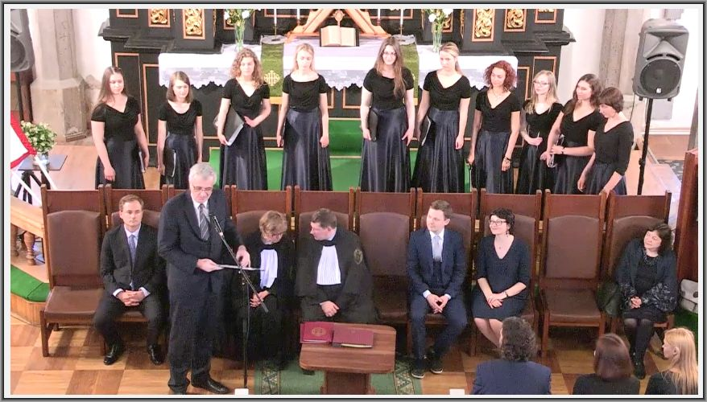
Remark: Signature under the photo - Upon invitation of Dean of Kaunas faculty of Vilnius University (on 401 place within the rank of world universities) colleague Assoc. Prof. Dr Kestutis Driaunys, Sabahudin Hadžialić held a speech at the graduation ceremony of students of VU Kaunas faculty on 16.6.2017 at 3 p.m. (CEST time - BiH time: 2 p.m.). Details: https://sabihadzi.weebly.com/lithuania-16062017.html

